CILIP Conference 2017
5th – 6th July 2017
Manchester
#CILIPConf2017

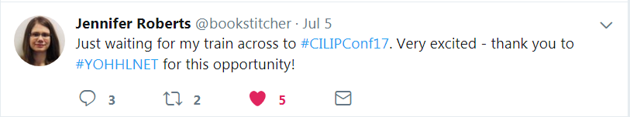
Text: “Just waiting for my train across to #CILIPConf17. Very excited - thank you to #YOHHLNET for this opportunity!”

The presentation that really struck me was …

Using the arts in libraries to benefit health and wellbeing, which was presented by staff from St Helens Council. Having worked with the Reading Agency’s Books on Prescription collections, I was fascinated by the ‘Arts on Prescription’ approach that the council was taking as this was very much bringing libraries, arts and culture together to improve health outcomes in the community.

The presenters, Sue Williamson (Head of Library Services) and Cath Shea (Arts Development Manager), spoke of the challenges they faced in a borough that experiences pronounced public health issues, from an above-average rate of COPD diagnoses to significant rates of child poverty. They also highlighted the level of information disconnect – 42% of the St Helens population did not engage with or lacked access to the internet – which makes the turnout for learning digital art platforms as part of the programme all the more significant.

The ‘Arts on Prescription’ programme was a way of bringing culture and art, which could seem intimidating or unfamiliar, closer to the local population by situating these within a familiar space: the library. The St Helens programme found that they were also engaging with groups that they wouldn’t ‘expect’ from previous library user demographics, particularly with young people and with men.

Sue and Cath ended on a discussion of how to develop and start similar projects; their advice boiled down to collaborative working with other organisations, building networks, and tackling the project as holistically as possible.

The workshop I found most useful was …

I had hoped to find the NPLN’s breakfast seminar, What I wish I learned in library school, more (directly) useful than it was. Firstly, the main presenter could only provide commentary on one of the accredited library degrees – understandably, as a founding member of the NPLN and a Manchester Met graduate. However, I felt that the ensuing discussion lacked nuance and could have been improved by including recent graduates from some of the other major library degrees, as a panel chaired by the NPLN.

Even as a paraprofessional yet to enter library school, I felt that a number of things raised during the discussion, the things that people wished they had learned, were things that I was already starting to develop! Skills like cataloguing and classification were highlighted repeatedly; literature searching was also mentioned. Less hands-on but equally important skills such as negotiating and teaching (especially vital in academic libraries, but also generally) were also felt to be neglected.

One point raised which I did find useful was that, knowledge-wise, a number of library degrees seemed to tend towards the academic and public library sectors, and that students / graduates wished they had the opportunity to learn about additional sectors such as law and health libraries. (Cue a sigh of relief from the health library trainee.)

Some members of the audience focussed on an ‘ethical responsibility as professionals to keep up to date’ – partly missing the points made by recent graduates, which was that they were finding it difficult to know “how” and sometimes felt that they were not receiving support when they sought it, whether from established colleagues or from regional CILIP hubs.

Frustrations aside, I did find the NPLN very interesting as a Northern, non-London network and I’m keen to engage with them in the future.

On the topic of workshops and presentations, I do regret not attending some of the health-focussed workshops – there were just too many sessions that caught my interest, and I ended up choosing by chance rather than with any sort of strategy. I would definitely try to plan ahead more if I attend another conference in the future.

The most engaging speaker was …

Keynote speakers Dr Carla Hayden (Librarian of Congress) and Neil MacInnes (Strategic Lead for culture in Manchester) were both phenomenal. However, Neil MacInnes’ keynote was particularly engaging after visiting Manchester Central Library the previous evening.

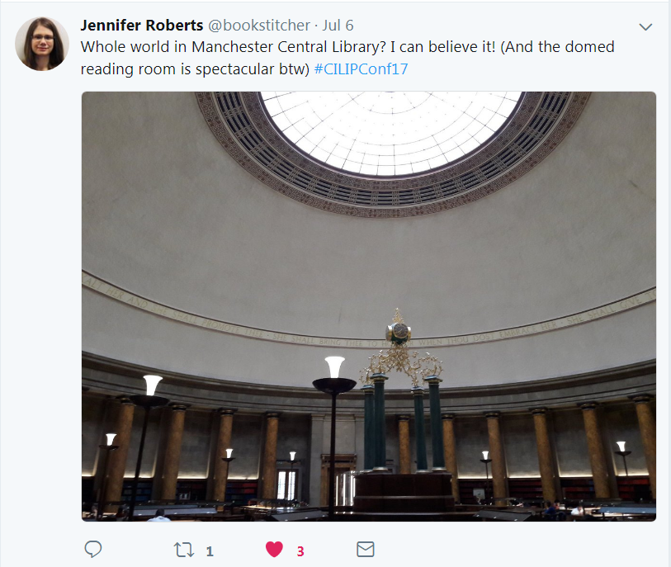
Text: “Whole world in Manchester Central Library? I can believe it! (And the domed reading room is spectacular btw) #CILIPConf17”. Image is of the central reading room, with an ornate clock at the heart of the room and a large circular window providing light from above.

A common theme in both keynotes was making information accessible. Dr Hayden talked to us about opening up the Library of Congress collections to a far wider audience, for example opening up the collections through wider use of information technologies, enabling the library to show items from the collection ‘live’ to a classroom in another state.

Meanwhile, Neil MacInnes illustrated the importance of renovating and improving library services – such as the refurbishment of Manchester Central Library – for the facilitation of access. I was particularly inspired by the folio of Shakespeare’s works which had only been consulted a handful of times before 2010; since the work was completed in 2014, this folio has now been seen by people across the city in schools and in smaller branch libraries. (Note: I used to work in a museum and have a bit of a passion for old things!)

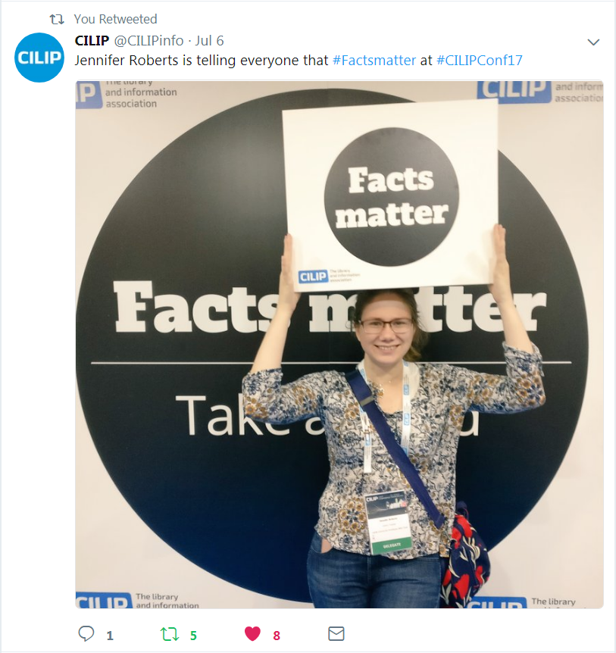
Text: "Jennifer is telling everyone that #Factsmatter at #CILIPConf17". Photograph shows me standing in front of a CILIP banner, and holding a 'Facts Matter' sign above my head.

I would recommend attending the CILIP conference because …

No matter the stage of your career, there’s an undeniable benefit in being able to meet people from right across the spectrum of libraries, information services, and knowledge management (as well as the world).

Jennifer Roberts
Library Trainee
Leeds Community Healthcare Trust

