Strategic Thinking for Healthcare LKS Professionals
Tools and techniques to align your NHS LKS strategy, and demonstrate the tangible value your service brings to support the wider ambitions of your host organisations.

23rd and 24th November 2017

Objectives for the event
- To understand and work with the constituent elements of research and the sections that make up a well-formed strategic plan
- To understand how to boil down an NHS organisation’s strategic plan to its essential componentry
- To be able to utilise the essential ‘plan on a page’ format to align your LKS strategy to you organisation’s strategies
- To familiarise ourselves with planning tools which will help us anchor our strategy tightly to that of our host organisations
- To utilise formats and vocabulary that make our strategy compelling and persuasive
- To consider how we work with our teams to create a strategy that has more buy-in from our team, because it has been co-created
- To manage the task of writing the strategy alongside the demands of business-as-usual
- To consider options for creating meaningful measures of success vs the strategy

What is strategy?
‘Strategy’ is a word which derives from the Ancient Greek, meaning ‘Generalship’: a leader on the field of battle is given the ultimate challenge of marshalling the resources at his control in the best way possible, to triumph over his adversaries.
The analogy may now be less literal, but the notion of strategy still relates to the research, thinking and planning process which enables an individual, team, department or organisation to use the resources they have available to create sustainable advantage and be successful in the markets they operate in (or could operate in).
Specifically for today, our purpose in this programme is to assist Library Services professionals in contributing to the development of a strategy which is meaningfully aligned with the strategy of their host organisation

How it all fits together

Vision statement
The far reaching aspiration of an organisation, dept or service. Remains over time

Mission statement
The purpose of the organisation, dept or service: the work we get up in the morning to do

Strategic) Priorities
- Goals….aims….priorities….strategic priorities….objectives… can all be synonyms
- They answer the ‘WHAT’ part of the strategy
- They are the direction of travel
- There are often top level 3-5 priorities. Sometimes there are more!

Strategies
The ‘HOW’. The directional ‘strands’
IKEA examples (made up for the purposes of the programme)
- To maintain our position at the leading edge of mass market homeware design
- To continue to build a brand synonymous with youthfulness, aspiration, happiness, family and home
- To defend our position from the ever increasing threat from online-only retailers
- To offer easy-to-install, efficient and environmentally considerate utilities and self-build options

Operational activities (tactics)
- These are the activities: the tangible jobs we leave the room and DO!
Example from A N Other Library Operational plan
Objective | Detail Description | Owner | Delivery Lead | Output | Start Date | Del Date
Develop dealing with difficult users and incident recording policy with actions | Establish procedure to report incidents in library spaces, aligned with University policy | Derek Jones | User Services | Policy introduced at staff meetings with appropriate training delivered and support tools identified | Sep-16 | Dec-16

Our strategic plans need to demonstrate at every level a clear line-of sight and linkage between our LKS ambitions and those of our host organisation(s)

Plan on a page format

Strategic Plan
Our vision
Purpose
(mission)
Strategic priorities (goals)
Core Strategies
Operational plans
Outcomes and metrics
Values
An approach to measuring impact based on the Balanced Scorecard

- Invented by Kaplan & Norton (1992, 1996).
- A strategic performance measurement framework, providing a comprehensive view of business performance and relating measurement, aligned to strategy, vision and mission

FINANCE: covers the financial objectives of an organisation and allows managers to track financial success and shareholder value.
CUSTOMER: covers the customer objectives such as customer satisfaction, market share goals as well as product and service attributes.
INTERNAL PROCESS: covers internal operational goals and outlines the key processes necessary to deliver the customer objectives.
LEARNING AND GROWTH: covers the intangible drivers of future success such as human capital, organisational capital and information capital including skills, training, organisational culture, leadership, systems and databases.
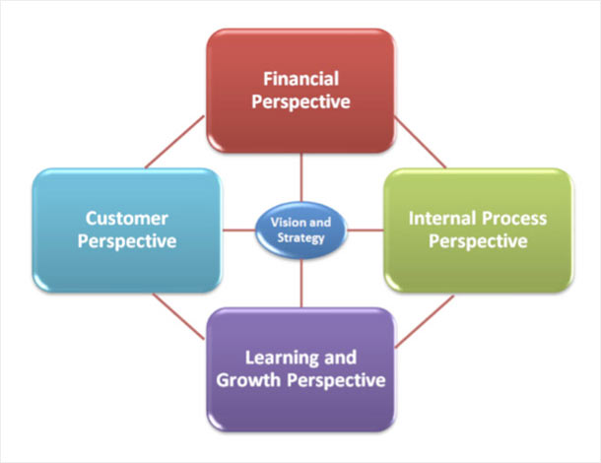

Not in itself a useful tool for NHS LKS, but can be adapted to create a visual, one-page set of impact measures that demonstrate how the ‘dial’ has been moved by the delivery of our strategies

Help! My trust has no strategic plan to align to!

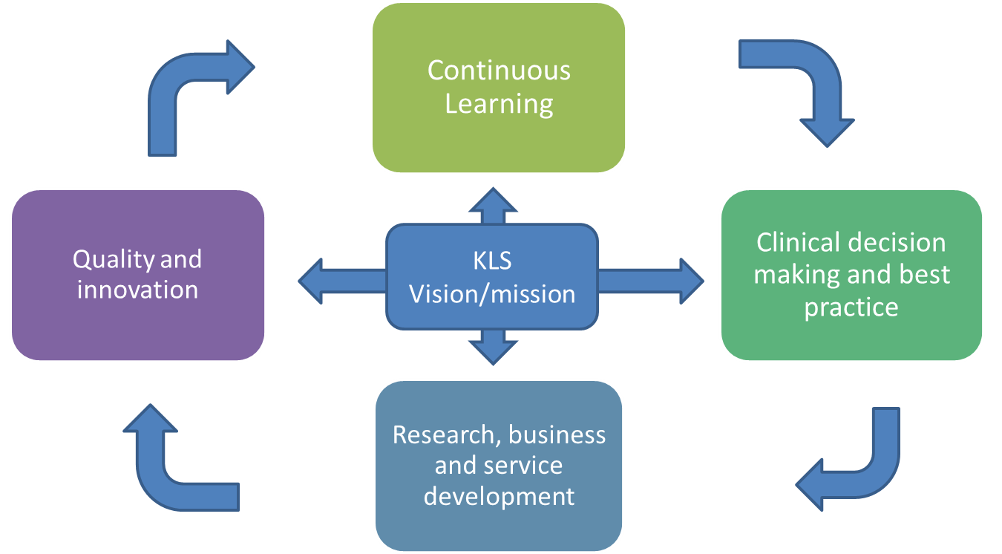

12 top tips to ensure every member of our team can fully participate in co-creating strategy

- Allow a couple of sessions to explain and work with concepts before moving to the NHS & KLS environment (separate concept and content)
- Use the ‘why, who, what, how’ triangle to help team understand the logical levels involved in writing strategy
- Start with examples outside KLS and healthcare in 1st instance (keep concept and content apart until the concepts are understood)
- Agree upon clear definitions and use the terms consistently
- Invite a more senior leader to talk to the team about the organisation’s most challenging or important priorities
- Clarify the idea of alignment (exist to serve the host organisations to reach their goals)
- Break down the Host Organisation strategy into a plan on a page together
- Use a ‘mapping exercise’ to help understanding of aligned strategy
- Give your team a chance to critique another NHS LKS plan-on-a-page to build confidence
- Start your LKS strategy with plan-on-a-page to make connections more visible and keep people ‘big picture’
- Mirror your ‘plan on a page’ with a balanced scorecard which reflects the measures that align with your strategic goals, which in turn align with you organisation’s goals
- Strategy is anything but stuffy. Make it fun. Bring it alive by drawing analogies with brands, markets and sectors from our everyday lives

