Using evidence in times of uncertainty
EBLIP10 Conference Reflections

Caroline Storer June 2019

Contents
About EBLIP 3
Keynote Presentations 4
Parallel Sessions 4
Posters 6
Summary 7

About EBLIP
This international conference has grown out of an increasing interest in using the best available evidence in health libraries to improve library and information practice more generally and is mirrored by the evidence based library & information practice journal .
Previous EBLIP conferences have been practical, friendly and inspirational in getting people involved in evidence-based practice. I have been privileged to attended EBLIP in Brisbane 2005, Stockholm 2009 and Salford 2011 so it was nice to return. 2019 is the third time the conference has taken place in the UK with the inaugural one in Sheffield in 2001.

The 10th International Evidence Based Library and Information Practice Conference was held at the University of Strathclyde, Glasgow 17th-19th June 2019.

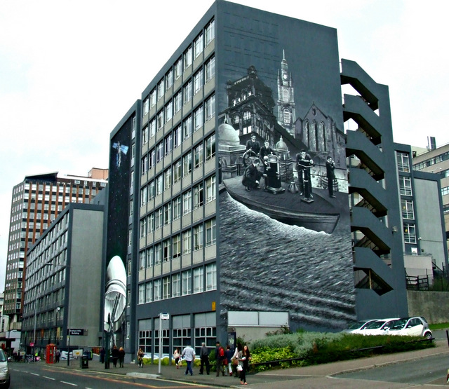

Conference Website https://www.eblip10.org/
Twitter #EBLIP10 @ConfEblip There was lots of tweeting so have a look!

The conference theme was “Using evidence in times of uncertainty”
In an era of library de-funding, calls for accountability, fake news, and complex information environments, evidence is becoming more important. This conference theme encouraged evidence based practitioners and researchers to think about what evidence is, how we collect it, and how we use it in these uncertain times.

John Scally, National Librarian of Scotland welcomed us to the conference. Politicians have not woken up to the implications of the internet, he said. The audience was encouraged to talk about stories, talk about people; humanising the facts and the evidence.

Keynote Presentations
The Opening keynote was delivered by our very own David Stewart, current CILIP President. David’s presentation title was "Biblio what?' Birmingham, Briggs and beyond: A practitioner's evidence journey" David reminded us that just because it’s published, it doesn’t mean it’s true. He told the story of his own journey in LKS. He spoke about having to wait a week for search results to be posted from Geneva. The Brigg’s report published in the 1980’s necessitated a need for Librarians to help nurses understand what research was. Later he was privileged to be in the centre of Evidence Based Medicine revolution in Oxford with Sir Muir Gray. From here the logical progression is Evidence-Based Everything.

The second Keynote was by Frankie Wilson, Head of Assessment at the Bodleian Libraries "Just do it! Don't let perfect be the enemy of action" who encouraged us to not let the best be the enemy of the good, but to just get on with it. Data should be reliable, replicable and trustworthy. It doesn’t have to be perfect. Look for trends rather than data being absolute. Frankie spoke about embedding a culture of evidence-informed decision making at Bodleian Libraries. She used the word informed rather than based because sometimes you have to do something which is not best practice because of funding or policy, something I can relate to. She said knowledge management doesn’t work if senior leadership in organisations don’t support it or practice it, nor does it work if staff aren’t doing it. Like John Scally she said tell a story, and re use other people’s work. Somebody else’s work can be evidence for your project and absence of evidence is not evidence of absence. She also said there’s a lack of data literacy in senior managers in organisations.

The closing keynote was by Donna Scheeder, past President of the International Federation of Library Associations "Telling the real story: Creating a global vision through data sharing" who introduced librarymap.ifla.org, a global map of library provision. It was a reminder of our worldwide mission. Donna highlighted that we need an evidence-based approach to our library advocacy. She said we embrace digital innovation but funding remains our greatest challenge, very true.

Parallel Sessions
The parallel session themes I chose to attend were:
- Using qualitative methods to demonstrate value and impact
- Digital and media literacy
- Meeting user needs
- New roles for health librarians
- Planning and evaluating services
- Digital Services
- National Initiatives for health libraries
Some take home points from the sessions I attended and some that colleagues attended are here:
Library Guides – when producing library guides, don’t use Library Jargon.

Nicola Pearce-Smith from PHE talked about the value and impact of literature searches. Case studies are a good way to tell a story. PHE call them ‘impact stories’. A one page A4 template sent to users 3 months after the search is done. Max 2 pages. Their annual review in 3 Powerpoint slides: 1 slide stats, 1 slide comments and 1 slide an evaluation wheel. Phelibrary.koha-ptfs.co.uk/stories

Digital Information Literacy - Katie Edwards and Christine Gallagher referenced the Topol review and The Knowledge Network Scotland, there was also a poster on this. They used Padlet which increased feedback received.

Paul Levay and Jenny Craven gave us an insight into the world of literature searching at NICE. They highlighted the challenge of new technologies and the need to adapt new search strategies. AI, text mining, data and analytics. I find this with the searches in my service. There was an interesting discussion about our job titles and how we describe ourselves – ‘Information Barista,’ is my new preferred job title! - I usually need a coffee to do a literature search and it fits in with randomised coffee trials and knowledge cafés.

Christine Wolff-Eisenberg – User questionnaires, the Interview script didn’t mention library, it started broader.

David Morgan – Evidence Gathering for project management. Supporting, planning, evaluating and implementing. Using project management methodology in library projects. Having a project plan detailing timescales and resources. Have a clear, concise project report and real timeline.

Hakan Carlsson – Writing a report after a questionnaire survey increases service change to 76%. Report-writing is a key step in changing services based on survey results. Analyse, reflect and change.

Karim Thoroni – Digital services. Karim spoke about Librarians having a role as practitioner-researchers. Also types of researchers being theory builders, practitioners and problem solvers. LIS research is too survey orientated; we need to do more action research.

Kathryn Barrett and Sabina Pagotto had introduced a digital ‘library chat’.

Clare Edwards and Dominic Gilroy of HEE narrated the process of developing the Quality Improvement and Outcomes Framework. In transitioning from LQAF, they emphasised it was a move from a compliance to a development approach. The new tool is for the organisation to show how it uses knowledge and its library staff, not just for the library. It is hoped it will highlight and share good practice and innovation.

Cecily Gilbert of the University of Melbourne delivered an interesting presentation based on the census of Australian health librarians. Their median age is 50-59, and are 88% female. We wondered what the position is in the UK? Sue Lacey Bryant tweeted some stats in response: 78% female and 55%45+ (whole workforce, not just healthcare).

Dominic Gilroy of HEE shared how difficult it has been to collate the quantitative data from the Value and Impact Toolkit questionnaire. It has nonetheless provided insights that have been used in the #amilliondecisions campaign and the KnowledgeShare for Healthcare Evaluation Framework.

Pip Divall of University Hospitals of Leicester NHS Trust reported back on the UK Clinical Librarian Impact Study. Interestingly they found that 67% of their queries came in by email, 25% in person. This shows the importance of developing good relationships. Curiously, given the history of Clinical Librarians, Ward Rounds we’re not found to be a time efficient way of obtaining search requests.

Alyson Tyler recounted how the social impact of Scottish mobile libraries was almost as important as the reading impact, and cannot be replicated by alternatives such as kiosks, postal loans or ebooks.

Posters
It’s worth making time to look at the posters at a conference, there were nearly 30 on display at EBLIP including one by Dom and Becky about developing the YOHHLNet network.
The others that were of particular interest to me were:
- Delivering a national digital library in times of austerity (The Knowledge Network Scotlandwww.knowledge.scot.nhs.uk). – relevant to me as we don’t have a physical library
- Research Impact and Value in LIS: introducing the RIVAL Network

Social Events
We were welcomed by a Civic Reception in Glasgow City Chambers in George Square.

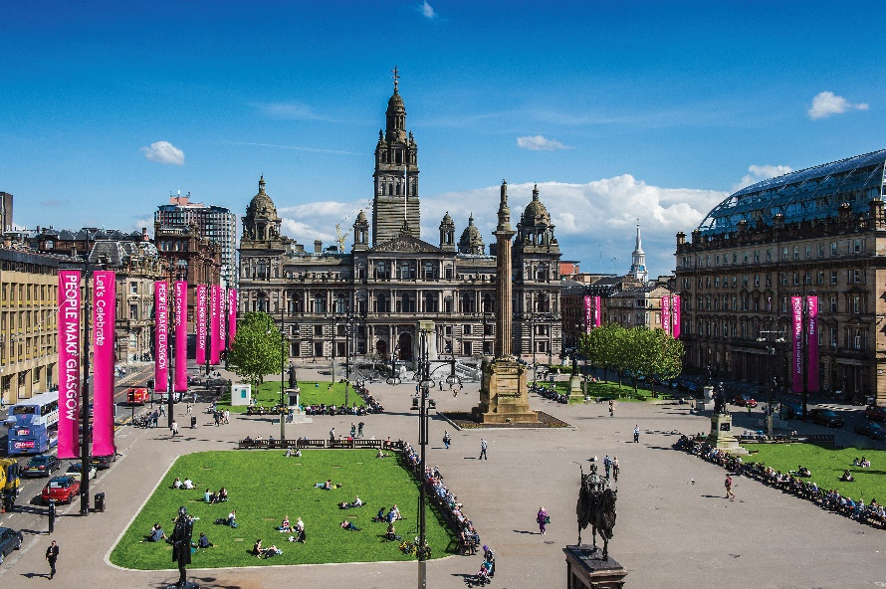

The conference dinner followed by a traditional Scottish Ceilidh took place at at Òran Mór (Gaelic for 'great melody of life' or 'big song'), which is in a beautiful former parish church in Glasgow's West End with an interesting history. Read about Alasdair Gray, an artist and native Glaswegian, who created the building's amazing ceiling mural. Both social events provided good opportunities for networking. There were additional tours organised to a whisky distillery and various local libraries.

Summary
Delegates at EBLIP are International, there were many from USA and Canada and from various sectors (not just health and social care and academia) so it was good to talk to practitioner researchers and hear about out good practice from further afield.
The key take home point for me was decision makers always want data and they need reliable data for funding. So what? Why should the decision makers care that our libraries exist? What they remember is the story. So, if your managers ask for data, shoehorn in the story.

It was a stimulating conference. The question now is: how can we and our services make useful and reliable additions to the evidence base for our practice.

Look out for the announcement of EBLIP11 which will be in 2021, it probably won’t be in Great Britain but don’t let that put you off, there was a virtual delegate option this time.

(With thanks to Stephen Ayre for his insights).

