ProQuest user guide

Accessing ProQuest Databases
Go to the library webpage www.mft.nhs.uk/library > Online resources > Healthcare Databases.
You will then see the ProQuest databases available to you. Login to the database of your choice using your OpenAthens username and password.
To make full use of a databases search features, click on Advanced Search
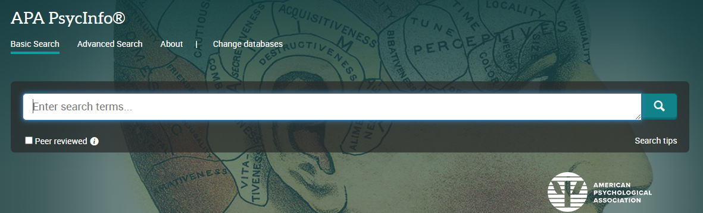
You will also need to register for a personal account so that you can save searches and results and access your ‘My research’ folder.
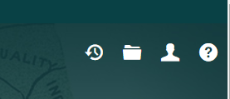

Keywords:
You can select Document title & abstract - TIAB from the drop-down menu to search the Title and Abstract together. Click on Recent Searches to search for the next search term(s). You will need to select Advanced Search again by clicking on the three horizontal lines on the top left-hand corner. Do this for all keywords.
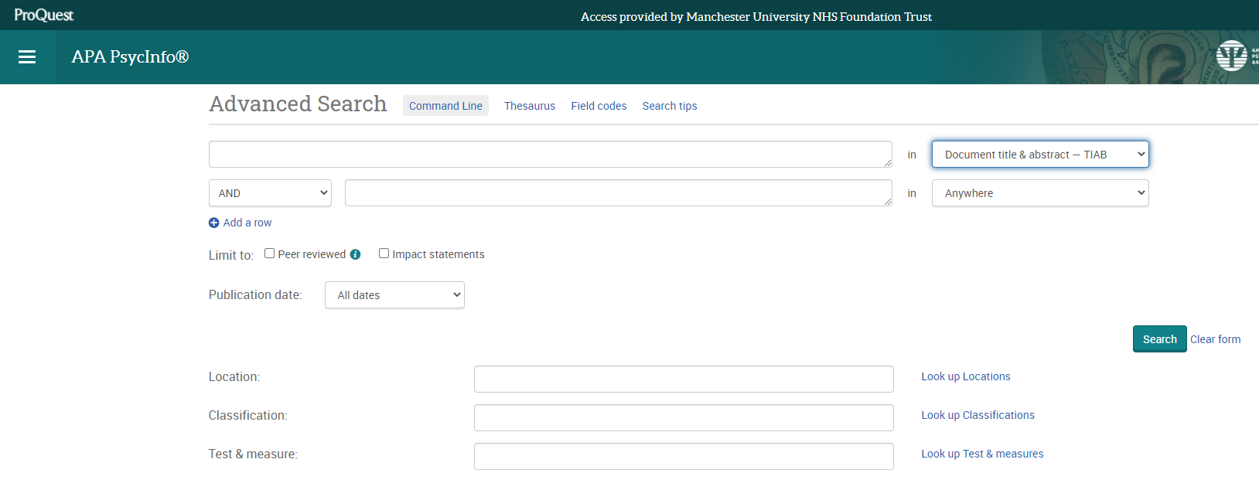
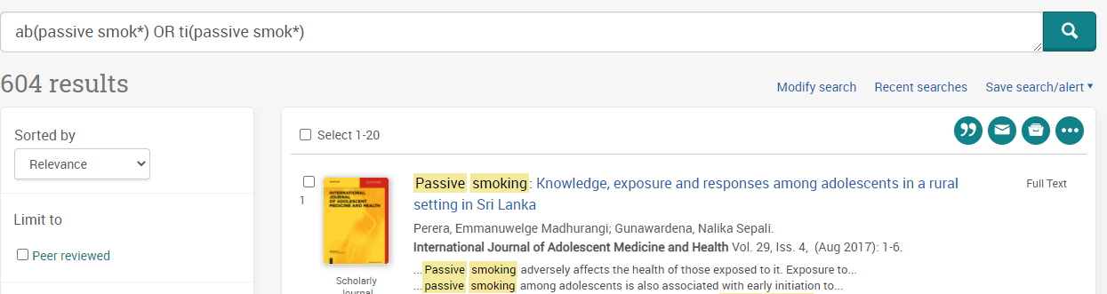

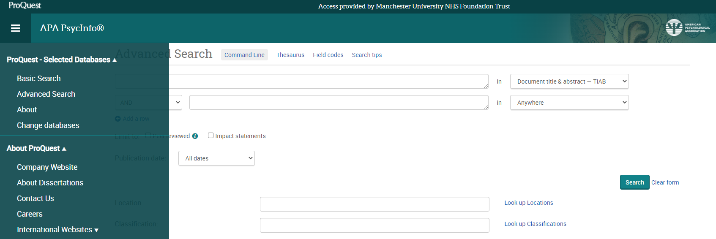

To search for Thesaurus terms, select Thesaurus from the menu bar. Tick the term(s) you want to use and click on Add to search (make certain to clear the search fields of previous keyword search):
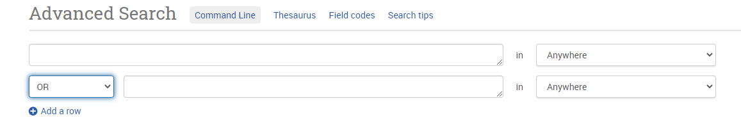
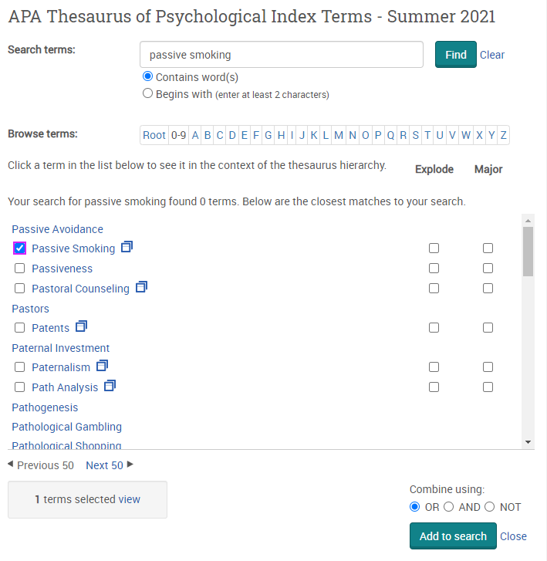

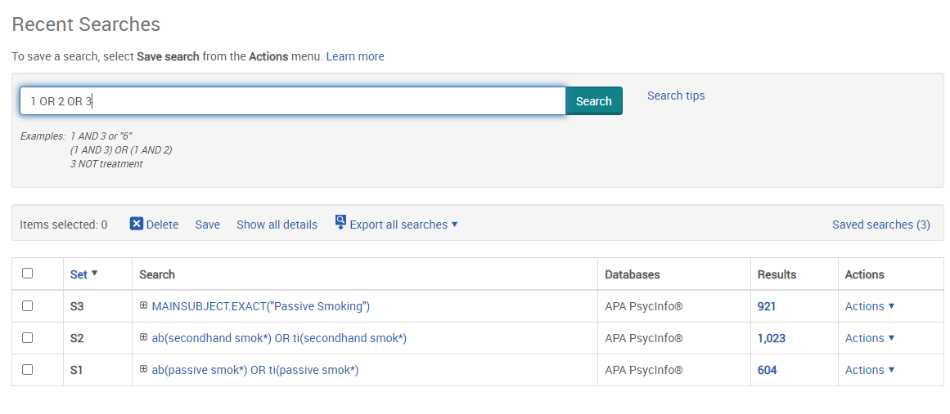
Then combine using OR as so: 1 OR 2 OR 3:

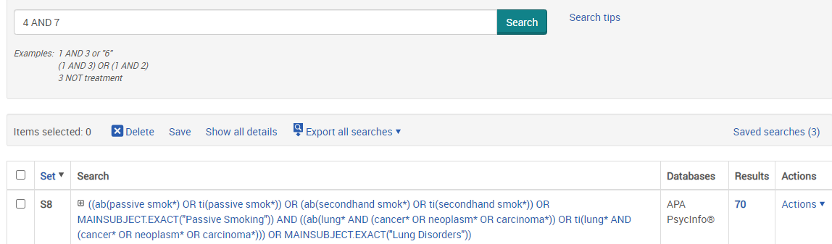
Then continue with the other concepts of your search. Once you have searched all your concepts, combine them using AND:

You can add filters such as age, gender, date etc. on the left-hand side of the page:
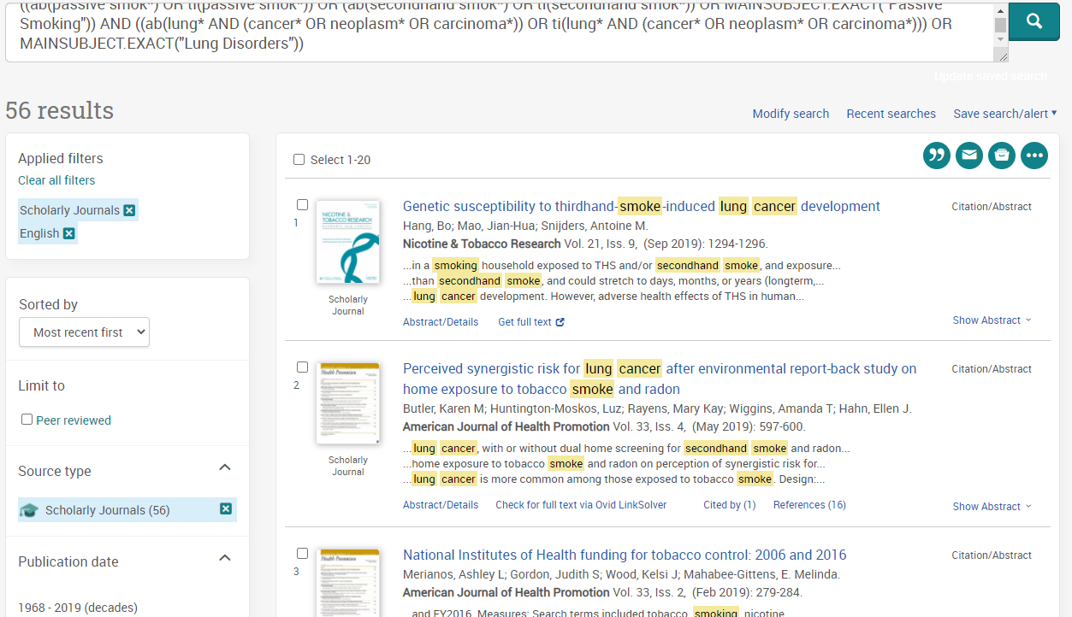

To export results, click on the three dots to export your selected results to an email, your Saved Research folder, as a text or PDF, or to a reference management system such as RefWorks. You can also use the ‘cite’ (the two inverted commas) to copy citations directly into a document. You can also export saved results directly from your ‘My Research’ folder.
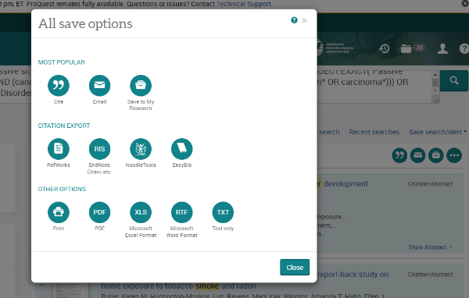
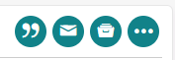

You can access saved searches either directly from your ‘My Research’ account’ or from the Recent Searches link on the database homepage.
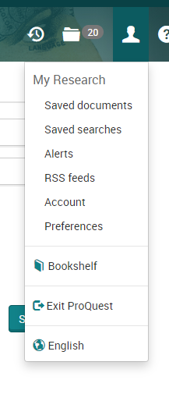
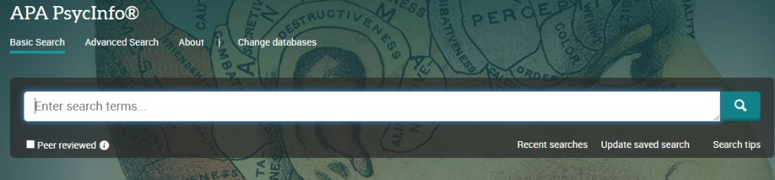

After searching a database, you then have the option to change to search on another database.
From the advanced search page, click on the database name to return to the basic search screen
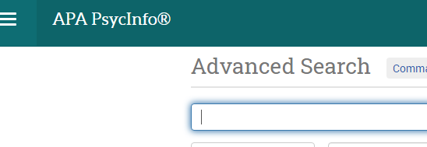

Then click on Change databases
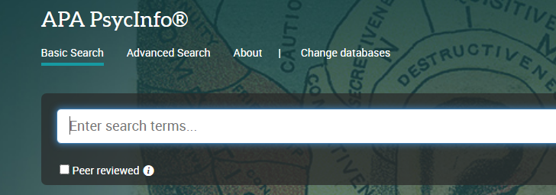

Then select the next database you wish to search
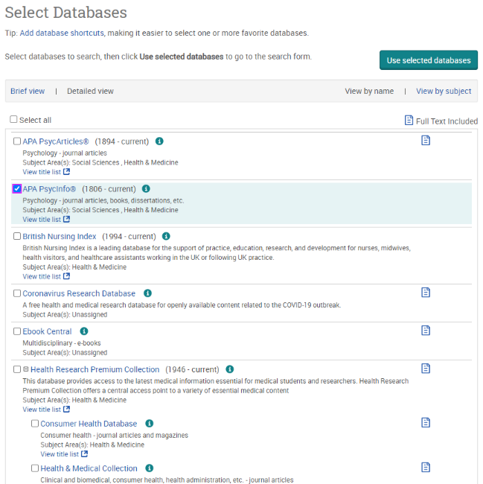

More questions? Book onto a training session with one of our librarians! The booking form is available from our Website: www.mft.nhs.uk/library

Olivia Schaff - Clinical Librarian & Outreach Librarian
Manchester University NHS Foundation Trust
Education South
Oxford Road, Manchester M13 9WL
Tel: 0161 276 11480
Trust Library Services
Here for you
Follow us
@mftlibraries

